25 Year Anniversary Shirt

“fighting natural selection since 1985”
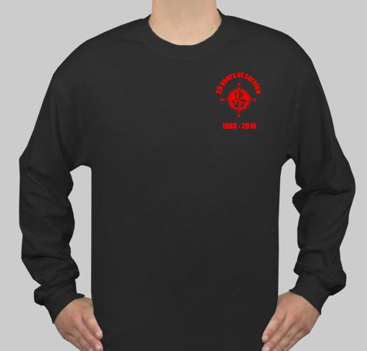
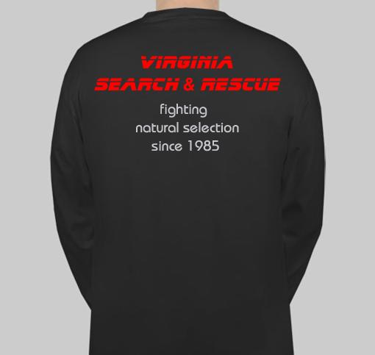

Black Haynes long-sleeve 100% cotton Beefy-T sizes S-M-L-XL-XXL-XXXL
Chest logo is a simple compass rose with “25 years of service” arching over the top and “1985 – 2010” under the logo. $15 each.

Search and Rescue became a standing program within the agency in 1985. Celebrate this milestone with a 25 year anniversary shirt!

NOT APPROPRIATE FOR WEAR ON MISSIONS

I need your orders (cash, check or money order) by October 16. Order goes in on Monday October 19 with two-week delivery. I anticipate having shirts ready for distribution at the second weekend of the SAR college (6-9 Nov.) I would like one person from each SAR group to coordinate and compile their group order for me. I will distribute back through the group representatives.

Name | Size | Price | Qty | Total
 |  | 15.00 x
 |  | 15.00 x
 |  | 15.00 x
 |  | 15.00 x

